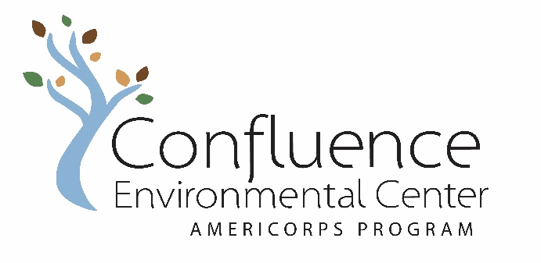

Final Member Self Evaluation

Member Name: Service Site:

Member Signature: Date:

Directions: Thoughtfully complete this form for yourself. Once it is completed, schedule a time to review it with your supervisor. Members will submit signed/dated evaluations at Feb + July Team Meetings.

Rubric:
5 – 4 = strongly agree (excellent - good)
3 = agree (satisfactory)
2 – 1 = strongly disagree (needs improvement - unsatisfactory)

Performance + Accomplishments | Rating

Reports to service site on time and prepared
Achieves project goals in a timely and effective manner
Works independently and is self-motivated
Takes initiative and exhibits creative thinking
Utilizes good judgment and takes project safety precautions
Seeks out and utilizes learning opportunities

Skills + Communication | Rating
Communicates respectfully with co-workers and stakeholders
Accepts feedback and uses it constructively
Has a positive attitude about national and community service
Identifies as an Confluence AmeriCorps member
Seeks out collaborative community projects

Describe your major accomplishments this half of your term.

What have been your major challenges this half of your term?
How did you manage these challenges?

How has this position developed your skills in advancing equity?

What are your final goals? Please list them here, review with your supervisor, and develop a strategy for achieving them.

Final Supervisor Evaluation of Member

Service Site:

Member Signature: Date:

Supervisor Signature: Date:

Directions: Thoughtfully complete this form for your Member(s). Once it is completed schedule a time to review it with your Member. Members will submit signed and dated evaluations at the Feb + JulyTeam Meetings.

Rubric:
5 – 4 = strongly agree (excellent - good)
3 = agree (satisfactory)
2 – 1 = strongly disagree (needs improvement - unsatisfactory)

Performance + Accomplishments | Rating

Reports to service site on time and prepared

Achieves project goals in a timely and effective manner

Works independently and is self-motivated

Takes initiative and exhibits creative thinking.

Utilizes good judgment and considers project safety precautions.

Seeks out and utilizes learning opportunities

Skills + Communication | Rating

Communicates respectfully with co-workers and stakeholders

Accepts feedback and uses it constructively
Has a positive attitude about national and community service
Identifies as an Confluence AmeriCorps member

What have been your Member’s major accomplishments this half of the term?

What skills has your Member demonstrated this half of the term?

How has your Member helped you advance equity and inclusion at your school or agency?

What has been the most rewarding aspect of supervising an AmeriCorps Member through Confluence?

What final goals would you like your Member to meet? Please list them here, review with your Member and develop a strategy to meet these goals.

Final Member Evaluation of Service Site

Member Name: Date:

Service Site: Supervisor Name:

Directions: Please thoughtfully describe how your service site has supported you in the areas below. Include suggestions for how the organization could better support you and/or Members in the future.

Workplan + Project Goals

Have you continued to use and update this document? Have you met the goals of your project? Were there any new goals that were created along the way, if so, what were they and were they met?

Tools + Resources

Do you continue to receive the tools and resources necessary to successfully complete your project? Were any new resources made available to you?

Site Supervisor Support

Does your supervisor continue to meet with you on a weekly basis? Are you still receiving valuable feedback and support for completing your project? Are there ways your supervisor could improve their support to you?

Project Sustainability

How will you present your project successes and challenges to the school, agency or stakeholders before your term of service ends? How will you thoughtfully transition the relationships you built so they are maintained after your term has ended? How will your projects be sustained after your term of service ends?

Site Specific Leadership Development

What kinds of leadership development (trainings, conferences, networking) have you participated in this half of the term? What other development activities are you still interested in?

Other Feedback Regarding Service Site

Anything else you would like share about your experience at this site?

Final Member Evaluation of Confluence

Member Name: Date:
Directions: Your final thoughts and impressions about your AmeriCorps experience are very important to us. Thank you for providing positive and constructive feedback.

Rubric:
5 – 4 = strongly agree (excellent - good)
3 = agree (satisfactory)
2 – 1 = strongly disagree (needs improvement - unsatisfactory)

Member Development | Rating
Participation increased your awareness and understanding of various concepts and skills.
Confluence trainers and speakers reflected diverse racial and cultural backgrounds
Devo activities and training fund was a valuable component of the program
Staff provided valuable and relevant devo days, opportunities and resources

Team Meetings and Service Days | Rating
Attendance was a valuable learning, networking and team building experience
Coordination and co-facilitation was a valuable leadership experience
Staff support and direction was readily accessible and helpful

Change Agent Project | Rating

Identifying and advancing a community identified need was a valuable engagement opportunity
Skills and experiences gained from your term of service helped you engage in a meaningful way
Staff support was accessible and useful

Member Experience | Rating
Did your Confluence AmeriCorps term of service meet your expectations?

Reflection

What have you discovered about your leadership as a result of your term of service?

Feedback Regarding Confluence

Anything else you would like share about your experience with Confluence or ways to improve our program?

Would you like to stay connected with Confluence as Alumni? Yes No

What is the best email address for you after your term ends?

Do you have plans for after AmeriCorps? Do tell!

