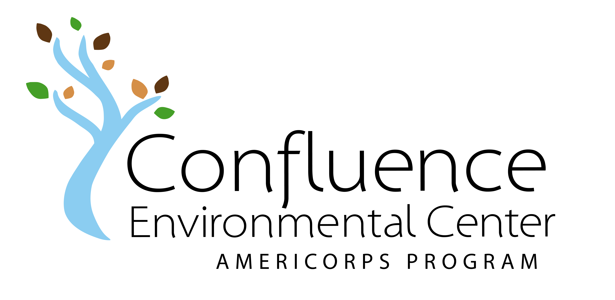

Final Member Self Evaluation

Member Name: Service Site:

Member Signature: Date:

Directions: Thoughtfully complete this form for yourself. Once it is completed, sign, date and schedule a time to review it with your supervisor. Members will submit signed/dated evaluations at Feb + June Team Meetings.

Rubric:
5 – 4 = strongly agree (excellent - good)
3 = agree (satisfactory)
2 – 1 = strongly disagree (needs improvement - unsatisfactory)

Performance + Accomplishments | Rating

Reports to service site punctually and prepared
Achieves project goals in a timely and effective manner
Works independently and is self-motivated
Takes initiative when appropriate and exhibits creative thinking
Utilizes good judgment and takes project safety precautions
Seeks out and utilizes learning opportunities

Skills, Professionalism + Communication | Rating
Communicates professionally with coworkers
Effectively leads and communicates with program stakeholders
Accepts feedback appropriately and uses it constructively
Projects a positive attitude about national and community service
Identifies as an Confluence AmeriCorps member
Seeks out collaborative community projects

Describe your major accomplishments this half of your term.

What have been your major challenges this half of your term?

How did you manage these challenges?

How has this position advanced your skills and awareness around environmental justice?

How has participating in this program changed you?

How will your AmeriCorps experience help you in the future?

Are there any final goals you’d like to meet? If so, list them here, share with your supervisor, and develop a strategy for meeting these goals.

Final Supervisor Evaluation of Member

Service Site:

Member Signature: Date:

Supervisor Signature: Date:

Directions: Thoughtfully complete this form for your Member(s). Once it is completed, sign, date and schedule a time to review it together. Members will submit signed/dated evaluations at the Feb + June Team Meetings.

Rubric:
5 – 4 = strongly agree (excellent - good)
3 = agree (satisfactory)
2 – 1 = strongly disagree (needs improvement - unsatisfactory)

Performance + Accomplishments | Rating

Reports to service site punctually and prepared

Achieves project goals in a timely and effective manner

Works independently and is self-motivated

Takes initiative when appropriate and exhibits creative thinking.

Utilizes good judgment and considers project safety precautions.

Seeks out and utilizes learning opportunities

Skills, Professionalism + Communication | Rating

Communicates professionally with co-workers

Effectively leads and communicates with program constituents

Accepts feedback appropriately and uses it constructively

Projects positive attitude about service / identifies as an AmeriCorps Member

Seeks out collaborative community projects

What have been your Member’s major accomplishments this half of the term?

What special skills has your Member demonstrated this half of the term?

Are there any areas you like to see your Member invest a bit more time and resources?

How has your Member helped you reach and engage communities of color and/or low income communities?

What has been the most rewarding aspect of hosting an AmeriCorps Member through Confluence?

Are there any final project goals you’d like to meet? If so, please list them here, share with your Member and develop a strategy to meet these goals.

Final Member Evaluation of Service Site

Member Name: Date:

Service Site: Supervisor Name:

Directions: Please thoughtfully describe how your service site has supported you in the areas below. Include suggestions for how the organization could better support you and/or Members in the future.

Workplan + Project Goals

Have you continued to use and update this document? Have you met the goals of your project? Were there any new goals that were created along the way, if so, were they met?

Tools + Resources

Do you continue to receive the tools and resources necessary to successfully complete your project? Were any new resources made available to you?

Site Supervisor Support

Does your supervisor continue to meet with you on a regular/weekly basis? Are you still receiving valuable feedback and support for completing your project? Are there ways your supervisor could improve their support to you?

Site Support of Member + Project

Will there be an opportunity for you to present your project successes and challenges to the organization/stakeholders before your term of service ends? What kinds of conversations have you had with your supervisor about project sustainability?

Site Specific Professional Development

What kinds of professional development (trainings, conferences, networking) have you participated in this half of the term?

Other Feedback Regarding Service Site

Would you recommend that Confluence continues to partner with your service site? Please explain.

Final Member Evaluation of Confluence

Member Name: Date:
Directions: Your final thoughts and impressions about your AmeriCorps experience are very important to us. Thank you for providing positive and constructive feedback.

Rubric:
5 – 4 = strongly agree (excellent - good)
3 = agree (satisfactory)
2 – 1 = strongly disagree (needs improvement - unsatisfactory)

Professional Development Series – Overall  (Leadership Compass, Equity Atlas, First Aid + CPR, CLF Conference – Pathways to Economic Justice, Volunteer Management + Service Learning, Conservation Education, Responsible Power, Restoration Planning, Grant Writing + Fund Development, Building Diverse Relationships) | Rating
Participation was a valuable networking and skill building experience
Confluence trainers represented a variety of backgrounds
Staff delivered clear communication and guidance

Team Meetings – Overall | Rating
Attendance was a valuable learning, networking and team building experience
Coordination and facilitation was a valuable leadership experience
Staff support and direction was readily accessible and helpful

Change Agent Project – Planning, execution + reflection | Rating
CAP planning and execution was a valuable leadership experience

CAP created space to become more involved in a specific community or personal cause
Staff support was readily accessible and useful

Overall Experience | Rating
Did your participation in the Confluence AmeriCorps Program meet your expectations?

Would you like to stay connected with Confluence as Alumni? Yes No

Would you like to be a Community Reader in future RFP processes? Yes No

What is the best email address for you?

What is the best mailing address for you?

What are your plans after AmeriCorps?

What final feedback do you have for Confluence?

